# Examination of the details of 2D vorticity generation around the airfoil during starting and stopping phases

## Alwin Wang

## Supervised By: Hugh Blackburn

### Introduction

Although vorticity is not a primary variable in fluid dynamics, it is an important derived variable for understanding and solving problems (Morton 1984). The Kutta-Joukowski Theorem (Equation 1) helps explain lift production by relating the lift per unit span and circulation, the flux of the vorticity (Anderson 2011). Used in conjunction with Kevin’s circulation theorem (shown in Figure 1a), many fundamental aerodynamics textbooks relate the generation of circulation around an airfoil to the starting vortex at the trailing edge produced by large velocity gradient (Anderson 2011, Torenbeek 2009). **Error! Reference source not found.**b shows an iconic pair of starting and stopping vortices observed in experiments by Prandtl, Tietjens and Müller (1957) experiments over 80 years ago.

  
$$\begin{aligned}L^{'}=ρ_{∞}V_{∞}Γ\#\left(1\right)\end{aligned} \\ \begin{aligned}Γ≡-\oint_{A}{V}⋅\text{d}s=-\iint_{S}{\left(∇×V\right)}⋅\text{d}S=-\iint_{S}{ω}⋅\text{d}S\#(2)\end{aligned}$$

**Figure 1(a): Circulation around an airfoil in inviscid incompressible flow or $ρ=ρ\left(p\right)$ (Anderson, 2011)**

  
**Figure 1(b): Snapshot from Prandtl’s flow visualisation film of a transient lifting airfoil**

While recent two-dimensional simulations have supported Prandtl’s main findings, additional phenomena have been discovered. For low Reynolds number airfoils Lei, Feng and Can (2013) discovered laminar separation bubbles on the upper surface that could cause periodic primary and secondary vortex shedding that varied with angle of attack. Numerical studies of viscous starting flows past wedges conducted by Xu (2016) detailed vorticity evolution directly applicable to finite-angle trailing edges of airfoils. Jones and Babinsky (2011) experimentally investigated the development of leading edge vortices on waving wings at low Reynolds numbers. Leading edge vortices were also observed by Vincent and Blackburn (2014) on airfoils during the stopping phase which questions the importance of vortex production on airfoil regions other than the trailing edge. Though there is an emphasis in current literature on vorticity generation at the trailing edge, this project will take a more holistic approach to investigating vorticity generation around a lifting body to better understand these phenomena.

During the starting and stopping phases of motion the airfoil, the vorticity production is due to the relative acceleration of the fluid and wall. It is recognised that the sources of vorticity must occur at the boundary of the fluid regions and for this scenario Morton (1984) outlines two production mechanisms as tangential pressure gradients from the fluid side and acceleration of the surface from the wall side. In either mechanism the vorticity is generated instantaneously and partially masked by viscous diffusion when there is constant generation (Morton 1984). These contributions were investigated by Blackburn and Henderson (1999) for vortex shedding of oscillating cylinders and it was noted the pressure-gradient generation mechanism could override the surface-acceleration generation mechanism and vice versa.

### Aims

This project will explore the vortex generation around an airfoil during acceleration and deceleration of the airfoil which has observed in earlier research. The first aspect of this project will require a literature review to appreciate the various phenomena already recorded and recreate them in a numerical simulation. The next aspect of the investigation will involve varying parameters such as the Reynolds number and calculating the strengths of various vortices produced around the airfoil by evaluating Equation 2. The last aspect of this project will analyse the contributions of the two vorticity generation mechanisms for various regions of the airfoil surface and how variables such as Reynolds number and acceleration affect the generation mechanism.

During the project it is expected these intermediate aims to shift or grow depending on the results from each stage and to ensure each aspect is thoroughly investigated to create a detailed examination of the vorticity generation about an airfoil. It is also expected that large amounts of data from simulations will be created and a secondary aim will be to create concise summaries and visualisations to explain phenomena observed. If possible, generalisations will be developed to create empirical correlations between variables. The other auxiliary aim of this project will be investigating the feasibility of porting code written for postprocessing into the source code of the numerical simulation to calculate derived quantities such as pressure gradients tangential.

### Methodology

While this investigation could be conducted experimentally, there would be significant barriers to overcome. For instance, the widely used method of particle image velocimetry would not be practical for such small time and length scales of initial vorticity generation and may addition of particles and dyes may cause results to not be representative of a homogeneous fluid. Inducing acceleration and deceleration of in the fluid without introducing turbulence would be near impossible and the alternative of moving the airfoil section would require some prior knowledge of airfoil drag to achieve desired motion. Another approach could be a theoretical examination of the flow but as this is a viscous, time-varying flow around a lift-producing airfoil there would be few (if any) complete theoretical results to guide this project. Without significant assumptions which would undermine the purpose of a detailed investigation, there is no guarantee a closed-form theoretical solution to vorticity generation exists as this flow is governed the Navier Stokes equation, one of the unsolved millennial problems.

As such, a numerical approach has been selected to overcome these difficulties and enable detailed analysis and understanding of the flow. The code used will be a spectral element method DNS code, semtex, that is convergent in both cylindrical and Cartesian coordinates (Blackburn and Sherwin 2004). The major limitation of this approach is there will not be a direct experimental result that can be used to validate the simulation flow field output. However, careful implementation of this numerical method and building upon validated results should negate this issue.

The scope of this project will be limited to two dimensional flows to reflect the initial Prandtl experiments and compare results to established literature. For similar reasons, low Reynolds numbers will be used, specifically between 1,000 and 10,000. Finally, the initial analysis will be limited to numerical simulations of a single airfoil, NACA0012, at a single angle of attack, 4 degrees. While this does reduce the capacity of this project it does reduce the computational resources required which allows for much finer investigation of time, Reynolds number, pressure gradient, acceleration and vorticity. The equations to be numerically solved are the two-dimensional incompressible Navier-Stokes equations in the acceleration reference frame shown in Equation 3 and the vorticity strength in the inertial reference frame at the surface of the airfoil shown in Equation 4 (Morton 1984).

$$\begin{aligned}\frac{∂u}{∂t}+u⋅∇u=-\frac{1}{ρ}∇p+\frac{1}{\text{Re}}∇^{2}u-a, ∇⋅u=0\#\left(3\right)\end{aligned}$$

$$\begin{aligned}-vn⋅∇ω=-n×\left(∇P+a\right)\#\left(4\right)\end{aligned}$$

### Project Plan

#### Simulation using Semtex

An earlier study was conducted by Vincent and Blackburn (2014) to establish the production of starting and stopping vortices and validation of results for the spectral element method (SEM) code Semtex. The initial work of this project will be to recreate these results for a NACA0012 airfoil at 4 degrees angle of attack and perform a convergence study to determine the optimal grid and SEM polynomial order. It may be found that different meshes or polynomial orders are required for different Reynolds numbers. A non-significant amount of time should be allocated to this validation and numerical convergence stage as it will be used as the basis for future simulations. Where possible, comparison to known or experimental results will be used to validate simulation results.

Once this is established, the next aim of this project will be to run simulations and determine vortex shedding in the starting and stopping phases. This will involve visualising the results from Semtex in a CFD visualisation tool such as Tecplot. This will be to visually inspect vortices produced including the trailing edge to satisfy the Kutta Condition and to guide the post processing analysis. In addition, the results should be checked for aliasing and/or discontinuities which may indicate a finer grid resolution and/or higher polynomial order required. While Tecplot does have advanced analysis features, for the range of parameters and detail for the investigation it has been decided custom code will be written to reduce the time required to manually process results in Tecplot.

The final aspect of the simulation will be to check correspondence between the two possible reference frames. Equation 3 outlines the Navier-Stokes equation in the accelerating reference frame, but it is also possible to simulate the motion in a stationary reference frame by providing a pressure differential as the inflow and outflow boundary condition. In theory both reference frames should produce the same result, but this should be validated.

#### Postprocessing of Numerical Results

A significant amount of time will be spent refining the mesh and polynomial order for the numerical simulation. However, the resulting point field will not on lines directly normal to the surface of the airfoil or streamwise tangential to the surface. An interpolation will be required to determine quantities of interest and/or conformally map the physical domain around the airfoil to a rectangular grid for a finite difference scheme. An example of the Semtex mesh and an interpolation to a surface-normal grid is presented in the Appendix.

For two-dimensional interpolation, there are several possible interpolation schemes including nearest neighbour, bilinear and bicubic. It is anticipated that a bicubic interpolation will result in the best result, but this could present numerical difficulties near the surface of the airfoil in the presence of discontinuities and/or large gradients. As such, it may be required that interpolation near the surface be treated with greater care and/or a different interpolation method used. Checks will be conducted to ensure mass, momentum and vorticity are still conserved and that the value of circulation is consistent between the Semtex mesh and interpolated surface-normal grid. As a final check, the interpolated quantities in surface-normal grid should be interpolated back onto the original Semtex mesh points and these quantities compared to the original output quantities to check for errors.

Once a satisfactory interpolation method has been determined, numerical differentiation can be used to determine the pressure differentials and other quantities required to solve Equations 3 and 4. The circulation around the airfoil will also be determined and the circulation of vortices (leading edge and trailing edge) calculated to investigate the contribution of each to Kelvin’s circulation theorem.

#### Analysis of Factors Contributing Vorticity Generation

While the Navier-Stokes equation provide a complete solution to describe the fluid, it will be interesting to determine any relations between the vortex generation and the parameter space including special location, pressure differentials, acceleration and Reynolds number (shown in Equation 5). However, as creating empirical relationships is not the primary aim of this project, it is only considered as a starting point for the detailed analysis.

$$\begin{aligned}\frac{\text{d}ω}{\text{d}t}=f\left(x,y,\frac{∂p}{∂n},\frac{∂p}{∂s},a,t,Re\right)\#\left(5\right)\end{aligned}$$

The contribution of each vorticity generation mechanism will also be investigated in detail. From the analysis of relationships between variables it may be possible to immediately identify, for example, the leading edge vorticity is dominated by pressure-gradient generation mechanism whereas the trailing edge vorticity is dominated by the surface-acceleration generation mechanism (current hypothesis of the author). By manipulating the boundary conditions of the airfoil to reduce the motion-induced vorticity in a similar manner to Blackburn and Henderson (1999), it may then be possible to test this hypothesis and determine the change in vorticity generation.

#### Extension to non-Lifting Bodies

Time permitting, it may be of interest to investigate the vorticity generation of non-lifting bodies. The first example will be the same airfoil, NACA0012, but at zero angle of attack. Since there is no lift generated it is anticipated there will be no starting or stopping vortex from the trailing edge, but the leading edge vortices may still be present. The next non-lifting body will be a cylinder to remove the effect of a sharp trailing edge. This analysis will be relatively easy to validate due to the abundance of literature on two dimensional viscous flow around a cylinder.

#### Proposed Timeline

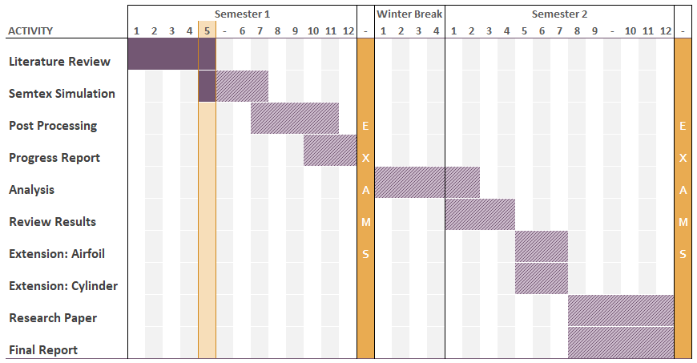

### References

Anderson, J.D., 2011. *Fundamentals of aerodynamics* 5th ed., NY McGraw-Hill, pp 174-177, 280-282, 330-338.

Blackburn, H. M. & Henderson, R. D. 1999. *A study of two-dimensional flow past an oscillating cylinder*, Journal of Fluid Mechanics, Vol 385, pp. 255-286.

Blackburn, H. M. & Sherwin S. J. 2004. *Formulation of a Galerkin spectral element–Fourier method for three-dimensional incompressible flows in cylindrical geometries*, Journal of Computational Physics, Vol 197, pp. 759–778.

Jones, A. & Babinsky, H. 2011. *Reynolds number effects on leading edge vortex development on a waving wing*, Exp Fluids 2011, pp. 197-210.

Lei, J., Feng, G. & Can, H. 2013. *Numerical study of separation on the trailing edge of a symmetrical airfoil at a low Reynolds number*, Chinese Journal of Aeronautics, pp.918-925.

Morton, B. R. 1984. *The generation and decay of vorticity*, Geophys. Astrophys. Fluid Dyn., Vol 28, pp. 277-308.

Prandtl, L & Tietjens, O.G., *Applied Hydro- and Aeromechanics*, Engineering Societies Monographs, 1934.

Torenbeek, E., Wittenberg, H & SpringerLink, 2009. *Flight physics: Essentials of aeronautical disciplines and technology, with historical notes*, London: Springer, pp 137-148.

Vincent, M. 2014. *Simulation of starting/stopping vortices for a lifting airfoil*, 19th Australasian Fluid Mechanics Conference, 8-11 December, Melbourne, Australia.

Xu, L., 2016. *Numerical study of viscous starting flow past wedges*, Journal of Fluid Mechanics, Vol 801, pp 150-165.

### Appendices

#### Boundary Conditions of Vincent and Blackburn (2014) Study

**Force**

$$\text{MOD_ALPHA_X}=-\left(\left(\frac{5π}{2}\sin\left(5πt\right)\right)H\left(t\right)+\left(-\frac{5π}{2}\sin\left(5πt\right)\right)H\left(t-0.2\right)+\left(-\frac{5π}{2}\sin\left(5πt\right)\right)H\left(t-0.8\right)+\left(-\frac{5π}{2}\sin\left(5πt\right)\right)H\left(t-1\right)\right)$$

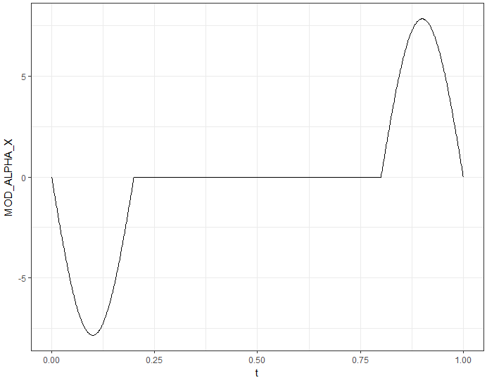  
**Figure 2: Body force in the $x$ direction of the airfoil.**

**BCS Number**

$$u = \left(\frac{1}{2}-\frac{1}{2}\cos\left(5πt\right)\right)H\left(t\right)+\left(\frac{1}{2}-\frac{1}{2}\cos\left(5πt+π\right)\right)H\left(t-0.2\right)+\left(-\frac{1}{2}-\frac{1}{2}\cos\left(5πt+π\right)\right)H\left(t-0.8\right)+\left(-\frac{1}{2}-\frac{1}{2}\cos\left(5πt+π\right)\right)H\left(t-1\right)$$

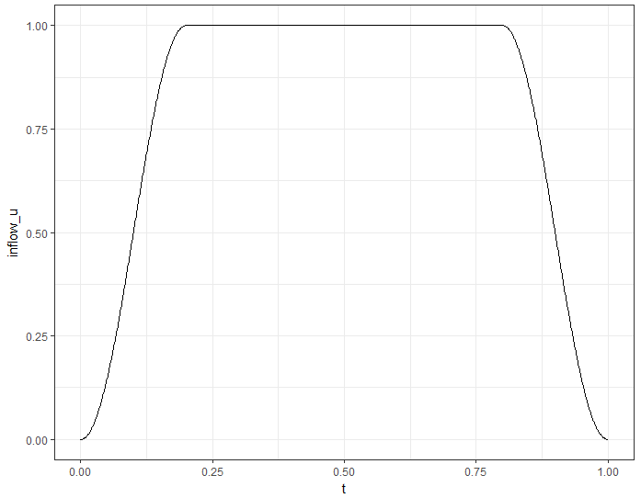  
**Figure 3: Inflow velocity in the $u$ direction.**

#### Mesh Types and Interpolation

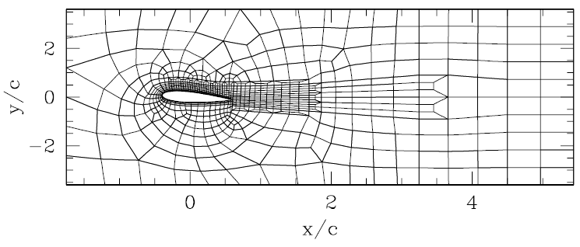  
**Figure 4: Semtex mesh used by Vincent and Blackburn (2014)**

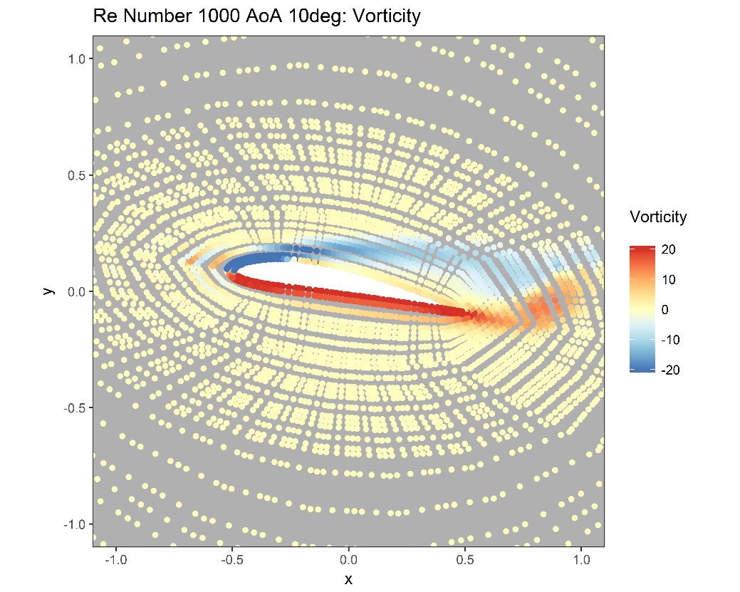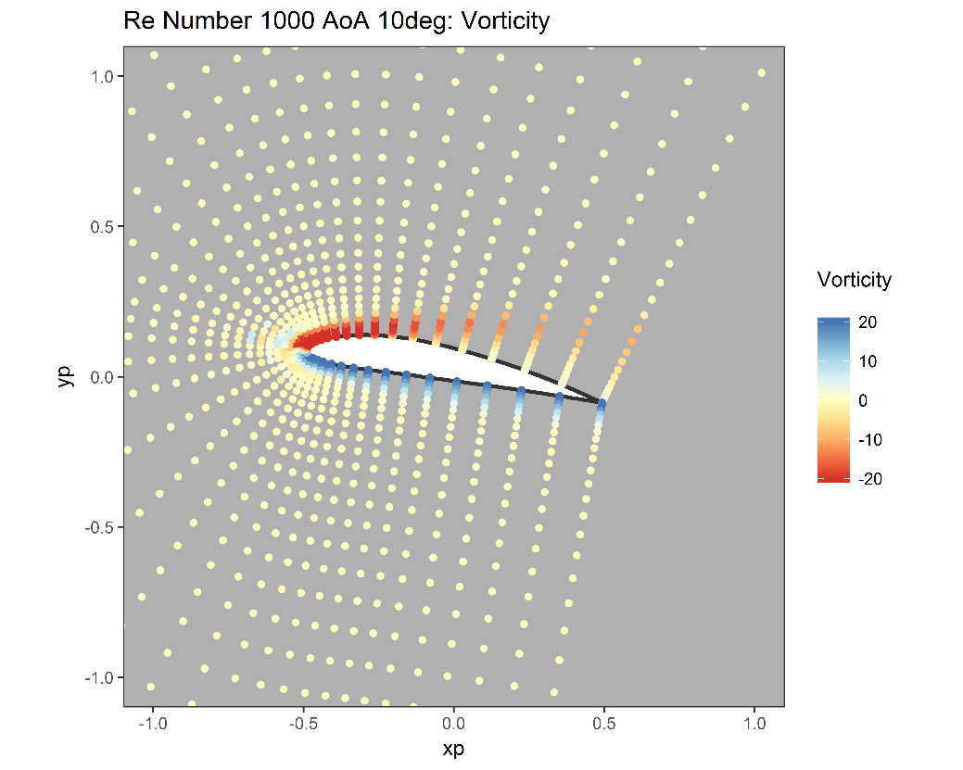

**Figure 5: Example of interpolation from mesh to surface-normal grid**

#### Risk Assessment

Please see attached.